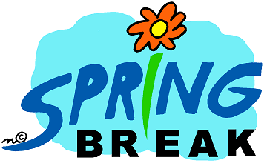

SCHEDULE
MARCH 25-29

MON-THURS: Open 6:00a – 4:00p
Family Swim 11:00a-12:45p
Public Swim 1:00-4:00p M-TH
NO evening aerobic classes

FRI: Open 6:00a – 12:00p

Saturday: 10:00a– 1:00p

